TITLE:_____________________________________ NAME:_______________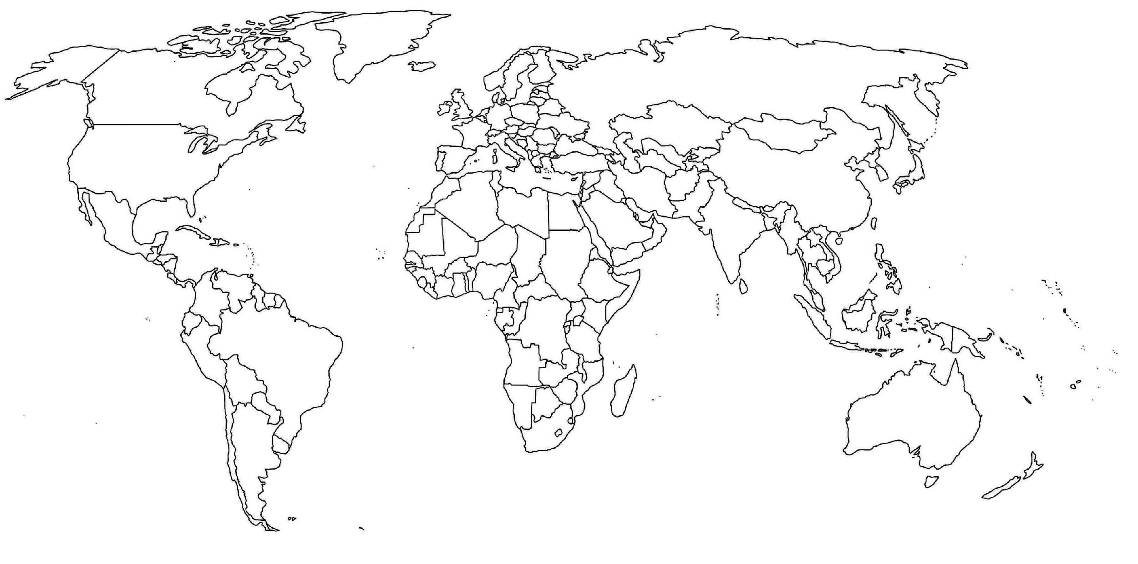

|  |  |  |  |
| --- | --- | --- | --- |
| **Top 10 Liveable Cities (2022)** | | **Bottom 10 Liveable Cities (2022)** | |
| 1. | 6. | 1. | 6. |
| 2. | 7. | 2. | 7. |
| 3. | 8. | 3. | 8. |
| 4. | 9. | 4. | 9. |
| 5. | 10. | 5. | 10. |